1st Nine Weeks Exam Review

**Safety**

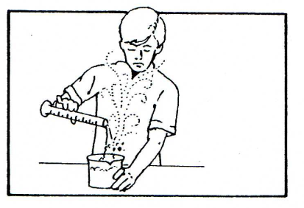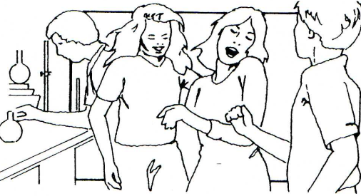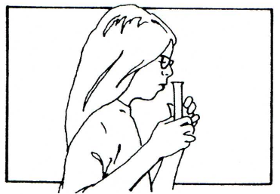Describe what is wrong with the following pictures (with lab safety in mind).

**Scientific Method (Parts of an Experiment)**

Identify the independent variable, dependent variable, control, and at least two constants for the following experiment:

The effects of caffeine on heart rate were tested. Four groups of 25 subjects were randomly selected and assigned. Each person’s pulse was taken at the start of the trial. Group 1 was given 1mg of caffeine; Group 2 was given 2mg; Group 3 was given 3 mg, and Group 4 was given a non-effective placebo. Thirty minutes after pill ingestion, each person’s pulse was taken.

What is the Independent Variable?

What is the Dependent Variable?

What is the control?

**Scientific Notation**

Write the following as either scientific notation or regular notation as appropriate.

|  |  |
| --- | --- |
| * 1001 |  |
| * 53 |  |
| * 6,926,300,000 |  |
| * 392 |  |
| * 0.00361  |  | | --- | | * 1.92 x 103 | | * 3.051x101 | | * 4.29 x 10-2 | | * 6.251 x 109 | | * 8.317 x 106 |  | |  |

**Measurements**

For each example, circle the more reasonable measure:

length of an ant 5mm or 5cm

length of an automobile 5 m or 50 m

distance from NY to LA 450 km or 4,500 km

height of a dining table 75 mm or 75 cm

Identify what each of the following would measure (length, mass, volume, temperature, time)

* 1. grams (g)
  2. liters (L)
  3. meters (m)
  4. centimeters (cm)
  5. kilograms (kg)
  6. centimeters cubed (cm3)
  7. degrees Celsius
  8. Seconds
  9. Kelvin
  10. milliseconds

**Dimensional Analysis (conversions)**

3.68 kg = __________ g

568 cm = __________ m

8700 mL = __________ L

25 mg = __________ g

600 g = __________ kg

0.250 kg = __________ mg

**Density**

Answer the following questions; show all work and remember to put the unit!!

* A block of wood has a density of 0.6 g/cm3 and a volume of 1.2 cm3. What is the mass of the block of wood?
* Identify the substance with a mass of 171g and volume of 15cm3.
* Identify the substance with measurements 250mL and 475g.
* Identify the substance with measurements 52g and 4.6mL.

**Classifying Matter**

Classify the following as either a substance or a mixture. If it is a substance further classify it as a compound or element; if it is a mixture, further classify it as heterogeneous or homogeneous.

* Mercury
* Table salt (NaCl)
* Pure Water (H2O)
* Coffee
* Air
* Vinegar (C2H3O2 + H2O)
* Carbon Dioxide (CO2)

**Physical/Chemical Properties**

Identify the following properties as chemical or physical- if physical further identify it as intensive or extensive.

|  |  |
| --- | --- |
| **Property** | **Chemical/Physical** |
| Solubility-*ability to dissolve in something* |  |
| Viscosity-*ability of liquid to flow* |  |
| Volume |  |
| Ability to Rust |  |
| Length |  |
| Mass |  |
| Combustibility*-how easily a substance will set on fire* |  |

**Physical/Chemical Changes**

Identify the following as chemical or physical changes:

* In baking biscuits and other quick breads, the baking powder reacts to release carbon dioxide bubbles. The carbon dioxide bubbles cause the dough to rise.
* Chewing food to break it down into smaller particles.
* Enzymes in saliva start breaking down the starches in food into sugars your body can use for energy.
* In a fireworks show, the fireworks explode giving off heat and light.
* An ice cube is placed in the sun. Later there is a puddle of water. Later still the puddle is gone.
* Two substances are mixed and light is produced

**Atomic Structure**

Label the parts of the atom below (nucleus, protons, electrons, neutrons):

+

+

What element is represented by this atom? Explain your reasoning.

What is the mass of this atom? Explain your reasoning.

What is the charge of the atom? Explain your reasoning.

**Isotopes**

Indium has two stable isotopes: Indium-113 and Indium-115.

Which of these do you think will be more abundant? Explain your reasoning.

Draw the other isotope symbol for each of the isotopes.

How many protons, electrons, and neutrons are in each isotope?

Element X has three isotopes: X-67, X-70, and X-72. These isotopes have 30%, 56%, and 14% abundances respectfully. Calculate the average atomic mass for element X. Show all work.

On the timeline below the significant event/discovery is placed. Add the date, person, and name of the atomic model.

Everything is made of tiny particles called atoms. No evidence so no one believed him

Matter is made up of atoms, that can not be subdivided further

Electrons Discovered

Atom has dense, positive nucleus-most of atom is empty space

Electron found to orbit nucleus in specific paths

Proton discovered in nucleus

Electron position can’t be found exactly. Electron cloud

Neutron discovered in nucleus