2017 International Conference on DNA
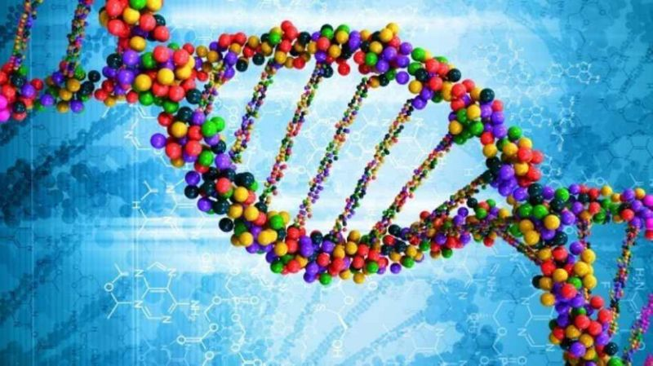
Welcome presenter and thank you for accepting to do this presentation. I know that we are going to have a great conference thanks to you. This is what we need you to know for your presentation and we will be informing you on what content you will be presenting at a later date.
You must have a 3D model of DNA with labeled parts for the
Nucleotide-and all its labeled parts and be specific on the different nitrogenous bases for DNA
Backbone and Rungs
Hydrogen bond

You need to be able to explain the basic structure and function of DNA, how it replicates to include all the players involved such as the enzymes involved and how, leading and lagging strands, and so on. Of course you also need to explain the importance of DNA and living organisms.

You also need to explain how the body makes proteins. Why proteins are important in our development so of course what function do proteins control in development of living organisms.
What is Genetic Engineering and how does it work?
You must explain
-Restrictive enzymes-what are they (naturally) and how do genetic engineers use them
-DNA ligase- what are they (naturally) and how do genetic engineers use them
-Plasmids what are they (naturally) and how do genetic engineers use them
-bacteriophages- what are they (naturally) and how do genetic engineers use them

Also explain bioengineering therapies such as
-Therapeutic proteins
-monoclonal antibodies
-peptibodies
-vaccines
What are they and how are they used for genetic engineering.

Time-line

DNA Model-April 13
Draft of all aspects of presentations-Up-loaded on Schoology by April 21
Presentations will be on April 28 the day of the conference.

