Name: _____________________________________________ Date: ____________________________ Period: ______

AP Biology Exam Review : Biochemistry (Unit 1)
Ms. Ottolini, 2012-2013

Textbook Chapters: 2 (Chemistry of Life), 3 (Properties of Water), 4 (Carbon Chemistry), and 5 (Macromolecules)

Helpful Videos and Animations:
- Bozeman Biology: Biological Molecules - https://www.youtube.com/watch?v=PYH63o10iTE&list=PLFCE4D99C4124A27A
- Bozeman Biology: Nucleic Acids - https://www.youtube.com/watch?v=NNASRkIU5Fw&list=PL7A750281106CD067&index=70
- Bozeman Biology: Lipids - https://www.youtube.com/watch?v=VGHD9e3yRIU&list=PL7A750281106CD067
- Bozeman Biology: Carbohydrates - https://www.youtube.com/watch?v=_zm_DyD6FJ0&list=PL7A750281106CD067
- Bozeman Biology: Proteins – https://www.youtube.com/watch?v=2Jgb_DpaQhM&list=PL7A750281106CD067
- Bozeman Biology: Polymers - https://www.youtube.com/watch?v=VigpwmH7E3M&list=PL7A750281106CD067

Topic Outline:

- Molecules and atoms from the environment are necessary to build new molecules
- Carbon (know where it is found in the four macromolecules and how it cycles between the environment and living organisms via the Carbon Cycle… see Ecology Unit)
- Nitrogen (know where it is found in proteins and nucleic acids and how it cycles between the environment and living organisms via the Nitrogen Cycle… see Ecology Unit)
- Phosphorus (know where it is found in lipids and nucleic acids and how it cycles between he environment and living organisms via the Phosphorus Cycle… see Ecology Unit)
- Know where/how oxygen, hydrogen, and sulfur are used in the macromolecules
CC – 2.A.3: 1. Carbon moves from the environment to organisms where it is used to build carbohydrates, proteins, lipids or nucleic acids. Carbon is used in storage compounds and cell formation in all organisms. Nitrogen moves from the environment to organisms where it is used in building proteins and nucleic acids. Phosphorus moves from the environment to organisms where it is used in nucleic acids and certain lipids.

- Bonds: Ionic, Covalent (Polar vs. Nonpolar), Hydrogen ; know the relative strengths of each bond and where they are used in nature
- Reactions of Life
- Dehydration Synthesis (releases water ; used to create polymers connected by covalent bonds ; anabolic ; endergonic)
- Hydrolysis (uses water ; used to break polymers into monomers by breaking covalent bonds ; catabolic ; exergonic)
- The Properties of Water (all come from water’s polarity and its ability to form hydrogen bonds ; understand how the structure of the water molecule is related to its function)
- Excellent solvent (know how water dissolves polar and ionic compounds we have water-based cellular fluids
- Cohesion and adhesion transpiration in plants
- Less dense as a solid prevents ponds and lakes from freezing solid
- High Heat Capacity / Specific Heat evaporative cooling (sweating) in animals ; moderates air temperatures near large bodies of water
- Macromolecules
- Carbohydrates
- Monomers = monosaccharides (know the basic structure and examples)
- Dimers = disaccharides (know the basic structure, how they form, and examples)
- Polymers = polysaccharides (know the basic structure, how they form, and the following examples – cellulose, starch, chitin, and glycogen)
Curriculum Connection (CC) – 4.A.1: We did not discuss how the different types of connections between glucose monomers in cellulose and starch chains give these molecules different structures / functions. Please use Chapter 5 in the textbook to review this concept.
- Lipids
- Basic structure (fatty acid chains and a polar region)
- Degree of saturation of fatty acid chains (# of H’s linked to carbons, which is inversely related to the number of hydrogen bonds) unsaturated fatty acid chains with kinks (liquid at room temperature) vs. saturated straight fatty acid chains (solid at room temperature)
- Functions = cell membrane (phospholipids), energy storage (fats, oils), steroid hormones like testosterone and estrogen (variations on a cholesterol 5-ring lipid)
CC – 4.A.1: In general, lipids are nonpolar; however, phospholipids exhibit structural properties, with polar regions that interact with other polar molecules such as water, and with nonpolar regions where differences in saturation determine the structure and function of lipids.
- Proteins
- Monomers = amino acids (know the basic structure ; the 20 different amino acids only differ in their R groups)
- Four levels of structure (primary, secondary, tertiary, and quaternary) = which types of bonds are found in each level? (covalent, hydrogen, hydrophobic interactions, van der Waals forces, ionic bonds, disulfide bridges) and where are the bonds being formed? (between adjacent amino and carboxyl groups? between nonadjacent amino and carboxyl groups? between R groups?)
- Many functions: enzymes (ex: amylase), structure (ex: keratin), transport (ex: hemoglobin), signaling (ex: oxytocin hormone)
CC – 4.A.1: In proteins, the specific order of amino acids in a polypeptide (primary structure) interacts with the environment to determine the overall shape of the protein, which also involves secondary tertiary and quaternary structure and, thus, its function. The R group of an amino acid can be categorized by chemical properties (hydrophobic,
hydrophilic and ionic), and the interactions of these R groups determine structure and function of that region of the protein.
Proteins have an amino (NH2) end and a carboxyl (COOH) end, and consist of a linear sequence of amino acids connected by the formation of peptide bonds by dehydration synthesis between the amino and carboxyl groups of adjacent monomers.
- Nucleic Acids
- Monomers = nucleotides (know the basic structure ; made of nitrogenous bases, phosphate groups, and deoxyribose sugars)
- Polymers = DNA and RNA
- In DNA, Nucleotides connected in two winding chains to form a double helix structure (how are they connected?)
- Function: storage and transmission of genetic information
CC – 4.A.1: In nucleic acids, biological information is encoded in sequences of nucleotide monomers. Each nucleotide has structural components: a five-carbon sugar (deoxyribose or ribose), a phosphate and a nitrogen base (adenine, thymine, guanine, cytosine or uracil). DNA and RNA differ in function and differ slightly in structure, and these
structural differences account for the differing functions.
Nucleic acids have ends, defined by the 3' and 5' carbons of the sugar in the nucleotide, that determine the direction in which complementary nucleotides are added during DNA synthesis and the direction in which transcription occurs (from 5' to 3').

Practice Multiple Choice Questions:

1. Which of the following is not a property of carbon?
a. | Carbon-to-carbon bonds are limited to single bonds.
b. | Carbon has four valence electrons.
c. | Carbon can form bonds to various other atoms.
d. | Carbon-to-carbon bonds are strong.

2. What aspect of long carbon chains makes them ideal for forming the backbones of long biomolecules?
a. | The carbon atom itself is strong and hard to split.
b. | Carbon can form a maximum of five covalent bonds with other atoms.
c. | Carbons can form a maximum of three covalent bonds with other atoms.
d. | Carbon-to-carbon covalent bonds are strong.

3. The chemical interactions of large hydrocarbons are largely determined by:
a. | their solubility in water.
b. | their functional groups.
c. | isomerization of these hydrocarbons into other forms.
d. | the hydrogens bonded to the carbon atoms.

4. Carbohydrate molecules:
a. | serve as structural components of human cell walls.
b. | form the regulatory compounds known as enzymes.
c. | are a source of energy.
d. | help protect vital organs from damage.

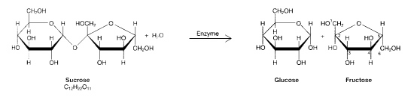
5. The process illustrated in the figure above is called:
a. | condensation.
b. | protein synthesis.
c. | hydrolysis.
d. | denaturation.

6. The products of the process in Figure 03-01 are:
a. | monosaccharides.
b. | molecules of glycerol.
c. | representative of a glycoside linkage.
d. | enzymes.
7. In which of the following reactions must the equivalent of a water molecule be added in order to break a bond?
a. | fatty acids + glycerol  fat
b. | glucose + fructose  sucrose
c. | glycogen  glucose
d. | alanine + glycine  dipeptide

8. Which of the following illustrates hydrolysis?
a. | the reaction of two monosaccharides to form a disaccharide
b. | the reaction of two amino acids to form a dipeptide
c. | the reaction of a hydrogen atom and a hydroxide ion to form water
d. | the reaction of a fat to form glycerol and fatty acids

9. Monosaccharides are water soluble because:
a. | they contain a large number of methyl groups.
b. | they have a large number of polar hydroxyl groups.
c. | they have large numbers of nonpolar carbons in their backbones.
d. | they can form ring structures.

10. The major function(s) of lipids includes:
a. | storing energy.
b. | serving as structural components of cellular membranes.
c. | A, B, and C are correct.
d. | Both A and B.

11. A molecule of a saturated triacylglycerol contains:
a. | the maximum number of double bonds between carbons in the fatty acid chains.
b. | the maximum number of triple bonds between carbons in the fatty acid chains.
c. | the maximum number of hydrogen atoms in the fatty acid chains.
d. | alternating single and double bonds between carbons in the fatty acid chains.

12. The major difference between a structural lipid and a storage fat is the fact that the structural lipid:
a. | most commonly contains phosphate.
b. | has four fatty acids attached to glucose.
c. | is entirely hydrophobic.
d. | 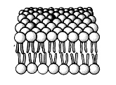  is nonpolar.

13. The most abundant molecules in this structure are:
a. | structural proteins.
b. | polysaccharides.
c. | triacylglycerols.
d. | phospholipids.

14. There are 20 different amino acids in the proteins that make up the tissues of living organisms. The primary difference between these amino acids is in their:
a. | R or variable groups.
b. | number of potassium groups.
c. | number of phosphate groups.
d. | number of asymmetric carbons.

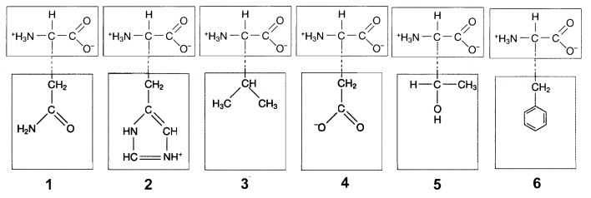
15. In Figure 03-02 (below), ionic attractions would form between the R groups of which amino acids?
a. | 1 and 3
b. | 2 and 4
c. | 3 and 5
d. | None of the above.

16. Hydrophobic interactions would occur between the R groups of which two amino acids in Figure 03-02?
a. | 1 and 4
b. | 2 and 5
c. | 3 and 6
d. | 3 and 5

17. Which of the following is responsible for the alpha-helical structure of proteins?
a. | hydrophobic interactions
b. | nonpolar covalent bonds
c. | 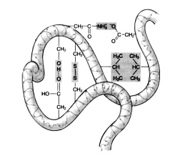  ionic interactions
d. | hydrogen bonds

18. At which level of protein structure are peptide bonds most important?
a. | primary
b. | secondary
c. | quaternary
d. | globular

19. Which of the following would help stabilize a protein the most?
a. | alpha helix
b. | beta pleated sheet
c. | hydrogen bonds
d. | disulfide bonds

20. All of the following types of chemical bonds are responsible for maintaining the tertiary structure of this polypeptide except:

a. | ionic bonds.
b. | peptide bonds.
c. | hydrophobic interactions.
d. | disulfide bonds.

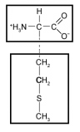
21. The following amino acid would be characterized as __________ based on the chemical properties of its side chain.

a. | nonpolar
b. | acidic
c. | basic
d. | hydrophilic

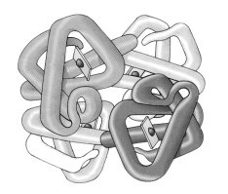
22. If the differently shaded portions of this molecule represent different polypeptide chains, then this figure is representative of:

a. | an amino acid.
b. | the quaternary structure of a protein.
c. | a steroid hormone.
d. | a carotenoid.

23.Analysis of a certain complex compound shows that it contains phosphate groups, ribose groups, and pyrimidines. Based on this information, which of the following is the best description of this compound?
a. | It is most likely ribonucleic acid.
b. | It is DNA.
c. | It is an inorganic compound.
d. | It contains thymine.

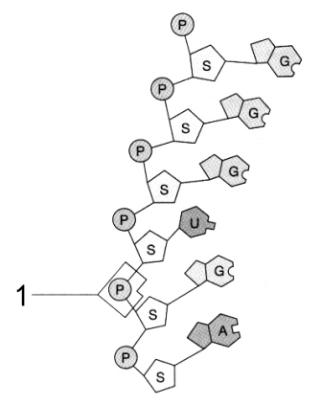
24. The molecular fragment represented in the figure to the right is:
a. | ATP.
b. | RNA.
c. | a nucleotide.
d. | a polysaccharide.

25. The type of connection between the atoms at the point labeled 1 in Figure 03-03 is:
a. | a peptide bond.
b. | a glycoside linkage.
c. | a disulfide bond.
d. | a phosphodiester linkage.

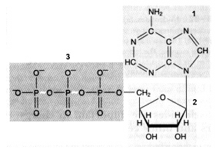
26. Which portion of the following molecule is easily transferred and therefore responsible for the energy transfer property of this molecule?
a. | 1
b. | 2
c. | 3
d. | None of the above.

27.Which monomer is incorrectly matched with the corresponding polymer?
a. | Amino acids are used to build proteins.
b. | Monosaccharides are used to build polysaccharides.
c. | Fatty acids are used to build nucleic acids.
d. | Glucose molecules are used to build starches.

28. It takes one calorie of heat to raise the temperature of one gram of water one degree Celsius at sea level. This is referred to as the _______________________ of water.
a. | heat of fusion
b. | heat of vaporization
c. | specific heat
d. | heat of transformation

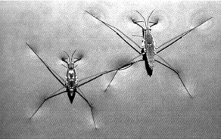
29. Which characteristic of water molecules directly contributes to the remarkable "water walking" success of the aquatic insects pictured in the accompanying figure?
a. | hydrogen bonds
b. | capillary action
c. | nonpolar covalent bonds
d. | ionic bonds

30. A stalk of celery is placed in a solution of blue colored dye. After one hour, the leaves have blue fluid in their veins. Which property of water is being demonstrated?
a. | adhesion and cohesion
b. | evaporation and cooling
c. | lower density as a solid than as a liquid
d. | high specific heat

31. Which of the following pairs of functional groups characterizes the structure of an amino acid?
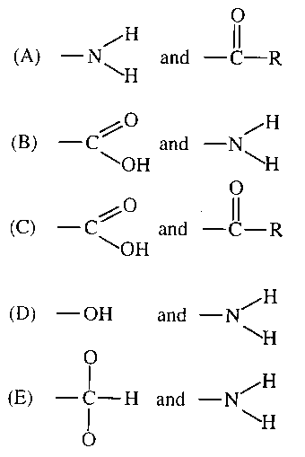

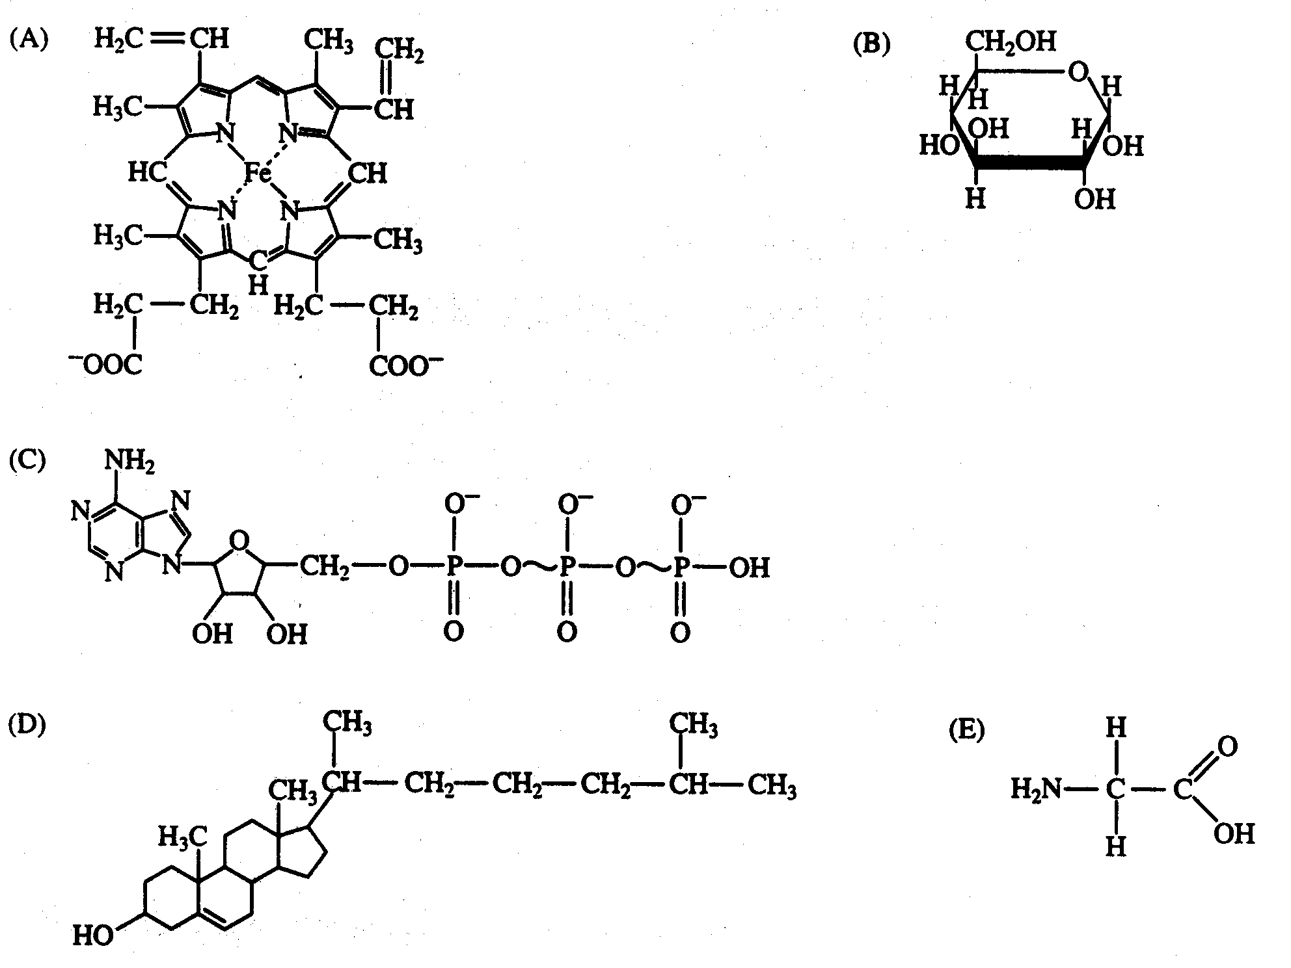

32. This molecule is used to transport oxygen
33. Starch is a polymer of this molecule.
34. This steroid molecule is found in cell membranes and is associated with atherosclerosis.
35. This molecule could result from the hydrolysis of a protein.
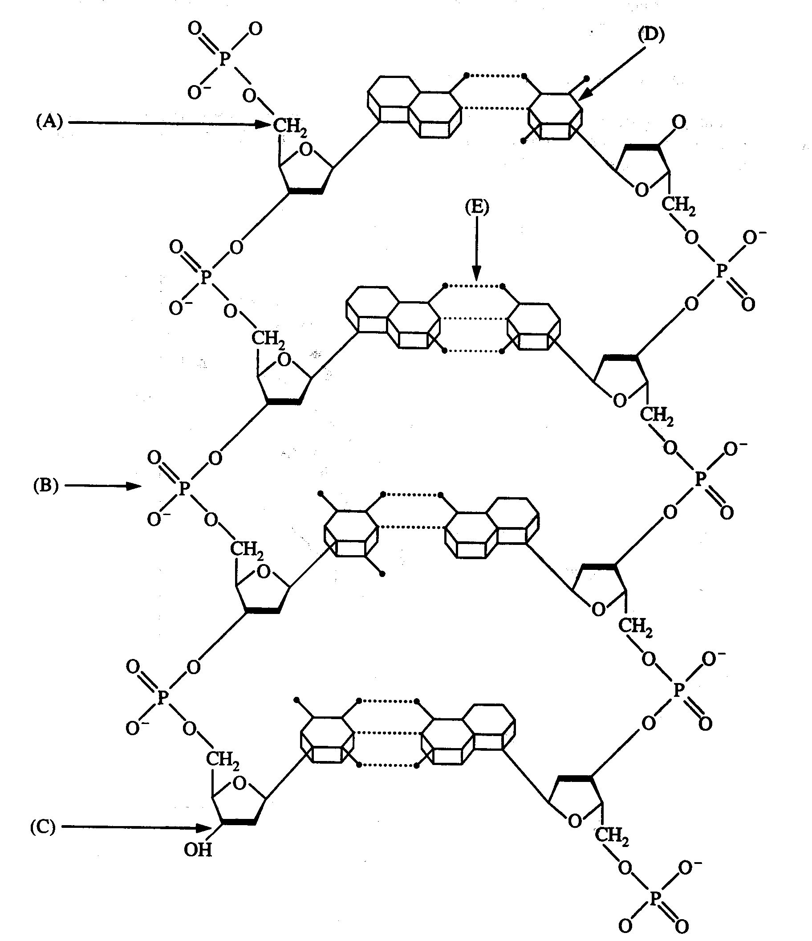
36. A chemical group that, together with a sugar and a nitrogen base, makes up a nucleotide
37. A hydrogen bond
38. A pyrimidine
39. A 5' carbon of deoxyribose
40. Most likely to be broken during replication

41. A feature of organic compounds NOT found in inorganic compounds is the presence of
(A)ionizing chemical groups
(B) electrons
(C) carbon atoms covalently bonded to each other
(D) oxygen

42. The carbon 'that makes up organic molecules in plants is derived directly from
(A) combustion of fuels
(B) carbon fixed in photosynthesis
(C) carbon dioxide produced in respiration
(D) carbon in the lithosphere

43. Which of the following macromolecules is primarily responsible for the insolubility of cell membranes in water?
(A) Starch
(B)Cellulose
(C) Protein
(D) Phospholipid

44. Which of the following is responsible for the cohesive property of water?
(A) Hydrogen bonds between the oxygen atoms of two adjacent water molecules
(B)Covalent bonds between the hydrogen atoms of two adjacent water molecules
(C) Hydrogen bonds between the oxygen atom of one water molecule and a hydrogen atom of another water molecule
(D) Covalent bonds between the oxygen atom of one water molecule and a hydrogen atom of another water molecule

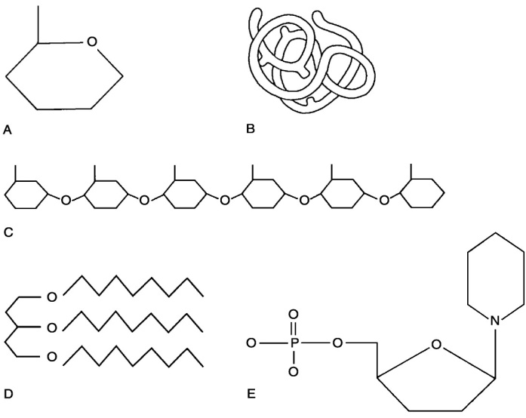

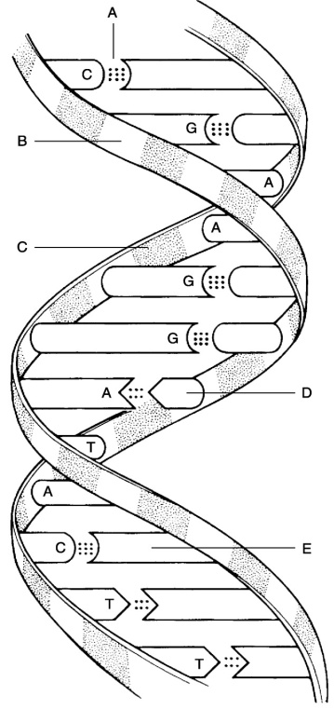
45. Lipid.
46. Functional protein.
47. Nucleotide.
48. Polysaccharide.
49. Monosaccharide.
50. Polymer
51. Tertiary (protein) structure

52. Deoxyribose sugar.
53.Thymine.
54.Guanine.
55.Phosphate
56.Hydrogen bonds.

57. Water molecules are transported from the roots to the leaves by way of the xylem. What property of water is responsible for maintaining the water column in the xylem?
a.) Water molecules ionize.
b.) Water molecules form intermolecular hydrogen bonds.
c.) Water is a good solvent.
d.) Water has a high heat capacity.
58. The bond between two atoms of the same element in which the electrons are equally shared is known as a nonpolar covalent bond. In a water molecule, the bond between one oxygen atom and two hydrogen atoms is known as a polar covalent bond and is a result of …
a) The individual bonds differ slightly in electronegativity
b) The valence shells of the two atoms are incomplete
c) There is an uneven distribution of charge between one atom of oxygen and two atoms of hydrogen
d) The oxygen atoms is the most electronegative of all elements
59. The figure on the next page shows the calories of heat energy required to convert a gram of water from solid to liquid state, and then again from liquid to a gaseous state. Especially distinctive is the large increase in energy required to move water from liquid to gas form.
This graph predicts which of the following properties of water that would affect plant survival?
a. Plant leaves doing transpiration are cooled down on hot days.
b. Inside a plant stem, cohesion attracts one water molecule to the water molecule above it, allowing a “chain” of water molecules to move up the stem.
c. At a plant’s roots, adhesion attracts water molecules to “stick” to root hairs, aiding absorption.
d. Sugar will dissolve in water, leading to a plant fluid called phloem, which typically flows from the leaves, down towards the roots.
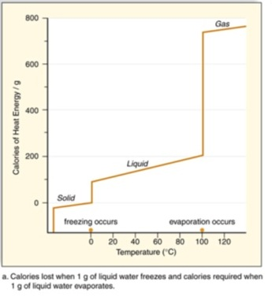
60. Why does the graph to the right show a dramatic increase in energy required to convert liquid water into water vapor?
a. Liquid water has a high heat capacity, and therefore adheres to cooler surfaces. This adhesion leads to a strong attraction of water to any non-water molecule.
b. Liquid water is an excellent solvent, and contains many solutes (sugar, salt, etc.) that dissolve within it; these solutes must crystallize and come out of solution in order for liquid water to turn into water vapor.
c. Liquid water is polar, and thus aligns molecules on a north-south axis; energy must be added to reverse the polarity of water and allow individual water molecules to become vaporized.
d. Liquid water is held together by hydrogen bonds between the water molecules; these bonds must become energized and break so evaporation can happen.
61. Chitin and cellulose are carbohydrate molecules that do not spontaneously break down but can be digested by bacteria and some other microorganisms. Since carbon is not among the most common elements in the earth's crust, what would happen if all of the chitin-digesting and cellulose-digesting organisms on the earth were destroyed?
a. Photosynthetic organisms would lack the carbon dioxide needed to create more carbohydrates, leading to their death, as well as the death of organisms that depend on them for food.
b. Photosynthetic organisms would take up chitin and cellulose from the soil, and use those to build new carbon containing compounds like proteins, lipids, and nucleic acids.
c. More carbon dioxide would build up in the atmosphere, leading to increased plant growth, as well as increased global warming.
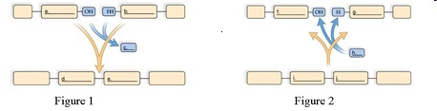
62. Which of the following pictures and descriptions shows the formation of polymers?
a. Figure 1, which shows dehydration synthesis.
b. Figure 1, which shows hydrolysis.
c. Figure 2, which shows dehydration synthesis.
d. Figure 2, which shows hydrolysis.
63. Air that is dry changes temperature quickly, while air that is moist retains it’s temperature. What property allows for this regulation of temperature?
a. The heat of fusion in of the nitrogen in the air, due to the free electrons.
b. The high electric potential of the air, which results from the static charges of the molecules in dry conditions.
c. The green house effect, due to the increase in carbon dioxide in the atomosphere.
d. The high specific heat of water, which results from the polarity and hydrogen bonding.

Practice Long Response Questions

1. 2003B:3
Water is important for all living organisms. The functions of water are directly related to its physical properties.
a. Describe how the properties of water contribute to TWO of the following
- transpiration
- thermoregulation in endotherms
- plasma membrane structure
b. Water serves as a reactant and a product in the carbon cycle. Discuss the role of water in the carbon cycle.
c. Discuss the impact of one human activity on the water cycle.

2. 2008:1
The physical structure of a protein often reflects and affects its function.
a. Describe THREE types of chemical bonds/interactions found in proteins. For each type, describe the role in determining protein structure.
b. Discuss how the structure of a protein affects the function of TWO of the following.
- muscle contraction
- regulation of enzyme activity
- cell signaling
c. Abnormal hemoglobin is the identifying characteristic of sickle cell anemia. Explain the genetic basis of abnormal hemoglobin. Explain why the sickle cell allele is selected for in certain areas of the world.

3. Earth is carbon based. Our carbon basis allows for the formation of complex molecules. Pick three of the four groups of complex carbon based molecules (macromolecules) and for each:
a) For each group, discuss the structural components of the molecule group.
b) For each group, discuss two examples of molecules that belong to each of the groups that
you chose. Briefly describe their function.
c) All of these groups of molecules are created from monomers joining to form polymers. Explain the process that joins these molecules.

