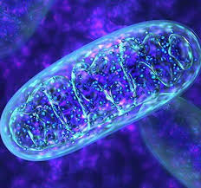
Vote for Mitochondria!
POW!
Tiny but mighty!
Why Vote for Me?

I can adapt to your needs!
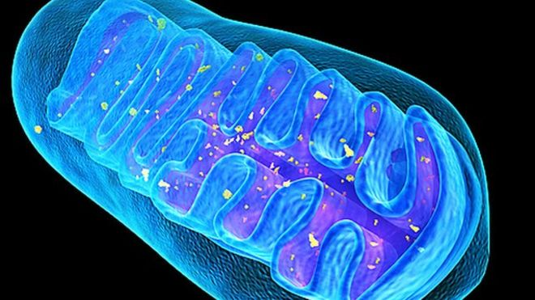
I provide energy for the cell and its organelles without wanting anything in return!

I’m found in both animal and plant cells!

