Prokaryote and Eukaryote Foldable
Front Side:
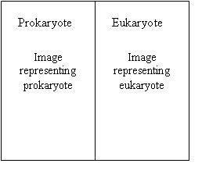
Define what a Prokaryotic Cell is
Define what a Eukaryotic cell is
Give example of each type of cell
Draw each type of cell
Inside:
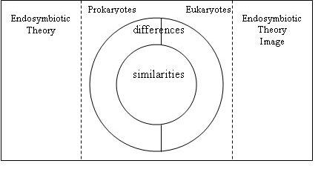
Requirements:
- At least 4 colors on EACH of the images
- Color Code your bulls eye
- Endosymbiotic theory MUST be described in your OWN words.
Cell Analogies:

An analogy is a comparison in which an idea or a thing is compared to another thing that is quite different from it.
It aims at explaining that idea or thing by comparing it to something that is familiar.

“Structure of an atom is like a solar system. Nucleus is the sun and electrons are the planets revolving around
their sun.”

You will be creating a foldable for Organelles
You will give the actually function of the organelle and an analogy for it.
You will draw a picture of the actual organelle and the analogy
They should be original ideas, different from the internet or your classmates

Example: Organelles-small structure within a cell that help the cell function. The organelles are like the organs
In our body, they organs help us function.

To make it easier for you, you can theme the organelle analogies, or you can just give analogies

Theme ideas:
School
City
Comic: Super hero’s/Super Villans
Store

The following organelles will have to have their own analogy:

Nucleus Golgi Apparatus (Body) Cytoplasm
Cell Wall Lysosomes Endoplasmic Reticulum (smooth, rough)
Cell membrane Mitochondria Vacuole
Ribosomes Chloroplast Flagella (Flagellum)

