Chemistry Final Semester 1 Review
You will be allowed to use your composition notebook, so if you need to take notes, I would put them there.
1. What is the proper method for determining the odor of an unknown substance?

2. In a lab activity a student has a clear, odorless liquid in a beaker. To dispose of this liquid the student should:

3. Place the number into Scientific notation: 0.00000425

4. A group of students goes mountain biking and in one day they traveled 100km. How many meters did they bike?

5. What is the length of the following line in millimeters? __________________________

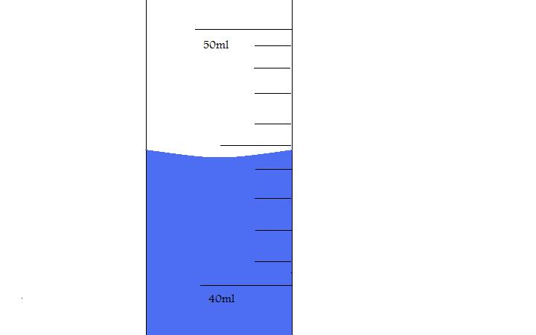
6. What is the volume of the liquid shown in the graduated cylinder?
50

40

7. A scientist tests a theory that balding people taking the supplement Biotin will help their hair grow back. Identify the independent variable.

8. A scientist tests a theory that balding people taking the supplement Biotin will help their hair grow back. Identify the dependent variable.

9. When working in laboratory activities you should always wear: Identify all the safety gear

10. Chemistry is the study of-

11. What are examples of matter?

12. What is physical property and what are some examples?

13. What are the states of matter and how do you identify them, what are their characteristics?

14. What are chemical properties and how can you identify them?

15. What are chemical changes and what are some examples?

16. What are Physical changes and what are some examples

17 Identify the following
- A compound:

- An element:

- A homogeneous mixture:

- A heterogeneous mixture:

18. What is a substance?

19. A material was found to have a mass of 270g and a volume of 30.0mL. What is the material made from? (this is a density question, calculate density)
Copper | Zinc | Gold | Aluminum | Brass
9.0g/mL | 7.1g/mL | 19.3g/mL | 2.7g/mL | 8.4g/mL

20. Who was first to suggest the existence of atoms?
A. Democritus
B. John Dalton
C. Atomos
D. Einstein

21. When looking at an element in the periodic table, what tells you how many protons will be in an element.

22. Who discovered the electrons were found in different energy levels orbiting the nucleus?
A. Dalton
B. Thomson
C. Rutherford
D. Bohr

23. How many neutrons are found in Hydrogen-3?

24. The picture shows a model of the element-

25. Which scientist discovered the electron by using cathode ray tubes and created the plum pudding model?
A. Dalton
B. Thomson
C. Rutherford
D. Bohr

26. How do you find the mass of an element?

27. Name the elements of the group on the periodic table?
Alkaline Metals Alkaline Earth Metals

Halogens Nobel Gases

Ga
31
68
28. How many neutrons does have?

29. In his gold foil experiment, who discovered the atom is mostly empty space with a dense positive nucleus in the center?
A. Dalton
B. Thomson
C. Rutherford
D. Heisenberg

30. What is the Lewis Dot Structure for Boron, B?

31. When looking at the periodic table, what is the trend for the atomic radius?

32. What is the Lewis Dot Structure for Alkaline Earth Metals?

33. Fluorine is a nonmetal. On the periodic table, fluorine is in Group 7 and Period 2. What elements are most likely to have similar properties as Fluorine?

34. What is the electron configuration of Phosphorus?

35. When looking at trends on the periodic table, what trend to you find for ionization energy?

36. What is the noble gas configuration for nitrogen?

37. When looking for trends in the periodic table, what are the trends for electronegativity?

38. When looking at trends in the periodic table, what are the trends for ionization energy?

39. What element has the following electron configuration: 1s²2s²2p⁶3s²3p⁶4s²3d¹⁰4p¹?

40. Sodium and Potassium have similar properties because-

41. What is the orbital diagram for Arsenic?

42. What must happen for Nitrogen to become an ion?

43. How does an atom become a cation?

44. How does an atom become a anion?

45. What charge do the Halogens get when they become ions?

46. What charge do Alkaline Metals have?

47. Why do elements want to have the electron arrangement of Noble Gases?

48. What noble gas will Magnesium look like when it becomes an ion?

49. What is the electron configuration of the ion Mg⁺²?

50. How would you correctly write the symbol for the ion of Potassium?

