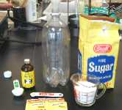 | FERMENTATION - MAKING ROOT BEER  David Fankhauser's Main Page | 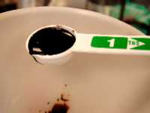
Introduction:
Fermentation has been used by mankind for thousands of years for raising bread, fermenting wine and brewing beer. The products of the fermentation of sugar by baker's yeast Saccharomyces cerevisiae (a fungus) are ethyl alcohol and carbon dioxide. Carbon dioxide causes bread to rise and gives effervescent drinks their bubbles. This action of yeast on sugar is used to 'carbonate' beverages, as in the addition of bubbles to champagne).
We will set up a fermentation in a closed system and capture the generated carbon dioxide to carbonate root beer. You may of course adjust the quantities of sugar and/or extract (Zatarain's) to taste.
 | EQUIPMENT | SUPPLIES
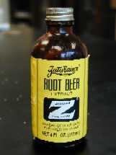 | - clean 2 liter plastic soft drink bottle with cap  - funnel  - 1 cup measuring cup  - 1/4 tsp measuring spoon  - 1 Tbl measuring spoon | - Cane (table) sugar [sucrose] (1 cup)  - Zatarain's Root Beer Extract (1 tablespoon)  - (When I could not find it locally, I ordered a case of 12 bottles for $18 from Zatarain's, New Orleans, LA 70114  - powdered baker's yeast (1/4 teaspoon) (Yeast for brewing would certainly work at least as well as baking yeast.)  - cold fresh water

INSTRUCTIONS:
 | 1) Assemble the necessary equipment and supplies
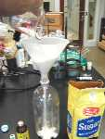 | 2) With a dry funnel, add in sequence:  1 level cup of table sugar (cane sugar) (You can adjust the amount to achieve the desired sweetness.)
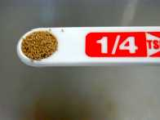 | 3) Add: 1/4 teaspoon powdered baker's yeast ( fresh and active)  (Fleischmann's or other brand)
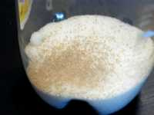 | 4) You can see the yeast granules on top of the sugar.
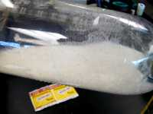 | 5) Shake to distribute the yeast grains into the sugar.
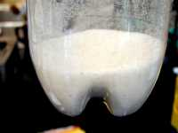 | 6) Swirl the sugar/yeast mixture in the bottom to make it concave (to catch the extract).
7) Add with funnel:
1 Tbl of root beer extract (I prefer Zatarain's, but Hires, etc. will work.)
on top of the dry sugar
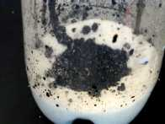 | 8) The extract sticks to the sugar which will help dissolve the extract in the next steps.

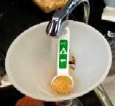 | 9) Half fill the bottle with fresh cool tap water (the less chlorine, the better).  Rinse in the extract which sticks to the tablespoon and funnel. Swirl to dissolve the ingredients.
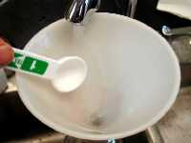 | 10) Q.s. [fill up] to the neck of the bottle with fresh cool tap water, leaving about an inch of head space, securely screw cap down to seal. Invert repeatedly to thoroughly dissolve.
If you leave it in a warm temperature longer than two weeks, you risk an explosion...
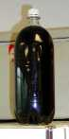 | 11) Place at room temperature about three to four days until the bottle feels hard to a forceful squeeze. Move to a cool place (below 65 F). refrigerate overnight to thoroughly chill before serving. Crack the lid of the thoroughly chilled root beer just a little to release the pressure slowly.  NOTE: Do not leave the finished root beer in a warm place once the bottle feels hard. After a couple weeks or so at room temperature, especially in the summer when the temperature is high, enough pressure may build up to explode the bottle! There is no danger of this if the finished root beer is refrigerated.
 | 12) Move to a refrigerator overnight before opening.
NOTE: There will be a sediment of yeast at the bottom of the bottle, so that the last bit of root beer will be turbid. Decant carefully if you wish to avoid this sediment.
A WORD ABOUT THE ALCOHOL IN HOME MADE ROOT BEER: The alcoholic content which results from the fermentation of this root beer and found it to be between 0.35 and 0.5 %. Comparing this to the 6% in many beers, it would require a person to drink about a gallon and a half of this root beer to be equivalent to one 12 ounce beer. I would call this amount of alcohol negligible, but for persons with metabolic problems who cannot metabolize alcohol properly, or religious prohibition against any alcohol, consumption should be limited or avoided.

