Frog Dissection - Teacher's Guide

Dissection Tips and Tricks
Obtain grass frogs from a biological supply company. I usually order mine from carolina. It is not necessary for this lab to get the injected frogs. I have also gotten a single pack of bullfrogs to give one per class. Bullfrogs are much larger, but that doesn't mean they are easier to dissect. The bullfrogs are messier and hard to cut, I have a "lottery" to pick a group to do the bullfrog and then the other students in the class can see what it looks like.
Group sizes - I usually put my students in groups of 2, possibly three if I have an odd number of students. If I have extra frogs I might allow students to work alone (their choice). Usually the students decide who is going to read / write, and who is going to do the cutting. I also use virtual frogs before the dissection to give them a clue about the structures they will see inside.
Lab Resources - The frog dissection gallery is a good resource for teachers and students to review the parts of the frog. I also encourage my students to try to discover the answers to their questions before asking for help. I have resources such as lab manuals and frog dissection guides laying around the lab. When students ask me questions, I require them to at least have a book open to the appropriate page to show me they tried to find the answer on their own. Remember that dissection is a learning process and part of the objectives should be to teach students to become independent learners. Younger students may need more help than older students.
Safety Considerations - students must wear safety goggles, frogs will sometimes spray fluid when you cut them and this fluid can be painful if it enters the eyes. If this happens, use eyewash and liberally flush eye with water. Latex gloves are preferred, but not entirely necessary. Students should wash hands even if they wore gloves.
Classroom Management - this can be a stressful time for teachers because students can get very excited and forget classroom rules. When you're helping one student, another may be throwing frog guts at their neighbors. Address these issues before you start the lab and make clear that horseplay will not be tolerated. Be prepared to enforce this. I typically end up removing a student from the class the first day, this student must do the alternate assignment in the hall. It sounds harsh, but if you're willing to give a bunch of 15 year olds scalpels, then be prepared to be very stern to ensure the safety of all of your students.
Grading - the dissection can be difficult to grade. I usually grade the questions and labelings from the Frog Dissection Handout and also give them a paricipation grade based on how well they did the lab, such as cutting the frog, cleaning up, and working well with others. Finally, students get a lab test over the frog where frogs have been set up and tagged; students move from station to station to identify the structures that have been pinned.

Key to Lab Handout Questions and Labeling
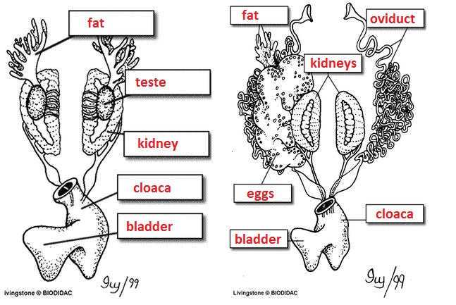

Post Lab Questions
1. The membrane holds the coils of the small intestine together: mesentery2.This organ is found under the liver, it stores bile: gall bladder
3. Name the 3 lobes of the liver: right, left anterior, left posterior
4. The organ that is the first major site of chemical digestion: stomach
5. Eggs, sperm, urine and wastes all empty into this structure: cloaca
6. The small intestine leads to the: large intestine
7. The esophagus leads to the: stomach
8. Yellowish structures that serve as an energy reserve: fat
9. The first part of the small intestine(straight part): duodenum
10. After food passes through the stomach it enters the: duodenum (sm intestine)
11. A spiderweb like membrane that covers the organs: peritoneum
12. Regulates the exit of partially digested food from the stomach: pyloric sphincter valve
13. The large intestine leads to the: cloaca
14. Organ found within the mesentery that stores blood: spleen
15. The largest organ in the body cavity: liver
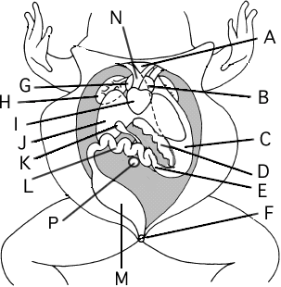

Label the Diagram
A. _________esophagus____________
B. _________left atrium_____________
C. _________stomach_____________
D. _________pancreas_____________
E. _________duodenum_____________
F. _________ anus________________
G. _________right atrium__________
H. _________lung________________
I. _________ventricle_____________
J. _________liver___________________
K. ________gall bladder______________
L. ________small intestine__________
M. ________cloaca (large intestine)______
N. ________conus arteriosus___________

Frog Anatomy and Dissection
In the lab, you will be spending a few days, dissecting the frog. Periodically, your instructor may pause to show you illustrations, diagrams or videos of procedures. This page is additional information that may be given to you in class as you perform the dissection.
Vomarine and Maxillary Teeth: Used for holding prey
Internal Nares (nostrils) breathing
Eustachian Tubes: equalize pressure in inner ear
Glottis : Tube leading to the lungs
Esophagus: Tube leading to the stomach
Tongue: Front attached, aids in grabbing prey
Tympanic Membrane: eardrum, located behind eyes
Nictitating Membrane: clear eyelid, protects the eye
Handouts on the Frog Dissection:
Frog External Anatomy
Frog Digestive and Urogenital System
Frog Brain and Bones

The Mouth
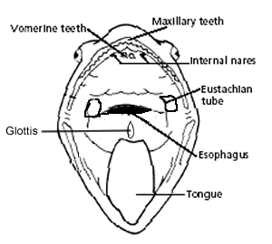

The Organs of the Abdominal Cavity
Peritoneum: Spiderweb like membrane that covers organs
Stomach: First site of chemical digestion, breaks down food
Liver: Makes bile (aids in digestion)
Gall bladder: Stores bile
Esophagus: Tube that leads to the stomach
Pancreas: Makes insulin (aids in digestion)
Small Intestine (duodenum and ileum): absorb nutrients from food
Mesentery: Holds coils of the small intestine together
Large Intestine: Collects waste, absorbs water
Cloaca: "Sewer": eggs, sperm, urine and feces enter this area
Spleen: Part of circulatory system, stores blood
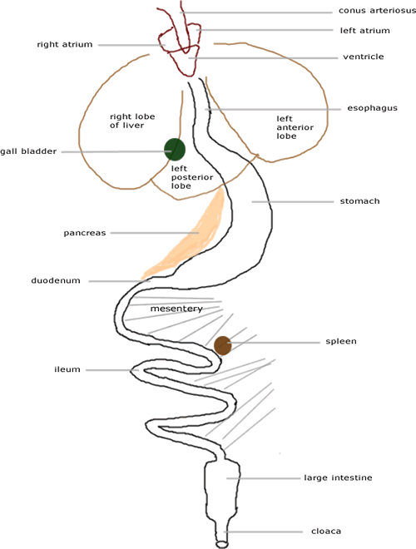

The Urogenital System
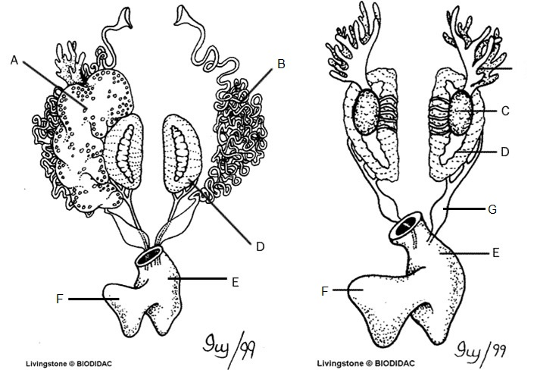
Kidneys (D): Filter Blood
Ureters (G): Carry urine from kidneys to bladder
Testes (C): Make sperm
Oviducts (B): eggs travel through these
Ovary: makes eggs (A) - ovary is often too small to see, but eggs are visible
Urinary Bladder (F): Stores Urine
Cloaca (E): Where sperm, eggs, urine, and feces exit.

