Fill in the following with the terms below:
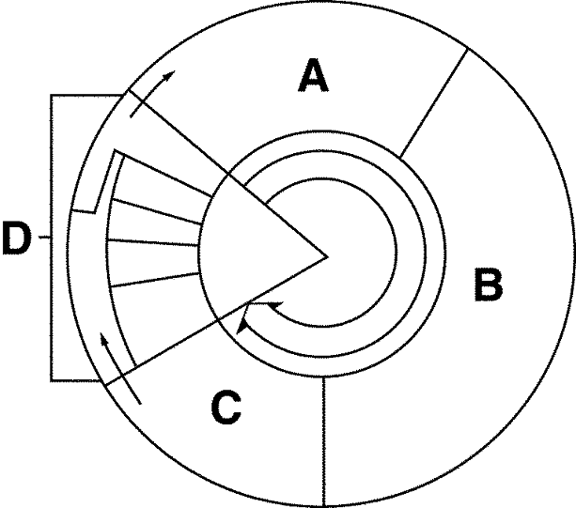
Interphase Prophase
G1 phase Anaphase
G2 phase Metaphase
S phase Telophase
M-phase Cytokinesis
Mitosis

What is going on in the following stages, or phases, be detailed:

Interphase:____________________________________________________________________________
_____________________________________________________________________________________
_____________________________________________________________________________________
_____________________________________________________________________________________

G1 phase: :____________________________________________________________________________
_____________________________________________________________________________________
_____________________________________________________________________________________

S phase: :____________________________________________________________________________
_____________________________________________________________________________________
_____________________________________________________________________________________

G2 phase:____________________________________________________________________________
_____________________________________________________________________________________
_____________________________________________________________________________________

M phase: ____________________________________________________________________________
_____________________________________________________________________________________
_____________________________________________________________________________________

Mitosis: : ____________________________________________________________________________
_____________________________________________________________________________________
_____________________________________________________________________________________

Cytokinesis: ____________________________________________________________________________
_____________________________________________________________________________________
_____________________________________________________________________________________

What is the difference between the cell cycle and mitosis? :
____________________________________________________________________________________
_____________________________________________________________________________________
_____________________________________________________________________________________

Mitosis
Identify the following phases, including interphase and the phases of mitosis as well as cytokinesis and describe in detail what is going on

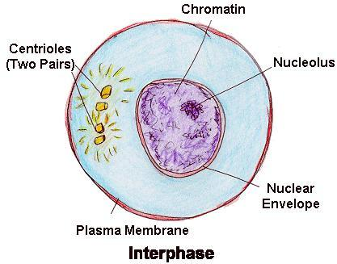

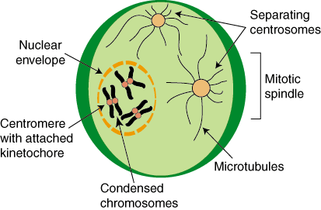

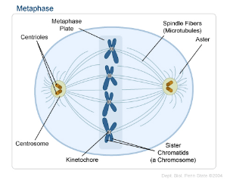

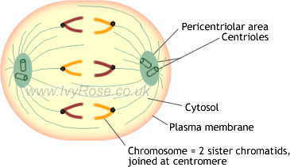

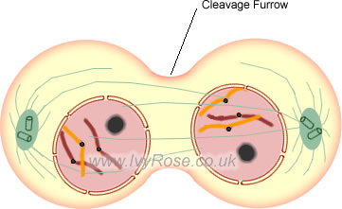

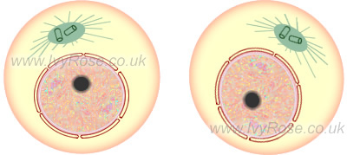

- In cytokinesis, how does an animal cell differ from the plant cell.

