Nanobacteria: Are They or Aren't They Alive?

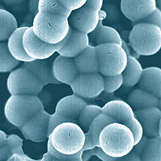

A Case Study on What It Means to Be a Biological Organism
by Merri Lynn Casem, Department of Biological Science , California State University, Fullerton (Adapted from: National Center for Case Study Teaching in Science)

Part I—What Does It Mean To Be Alive?

Biology is the study of living things. Whether a single cell or a Sequoia tree, a humpback whale or a human being, you have an intuitive sense of what it means to be a biological organism. Sometimes, however, the designation of something as a living thing is not so obvious. A recent example of this is the discovery of nanobacteria.

Bacteria are prokaryotic cells. Prokaryotes lack the internal, membrane-bound structures associated with eukaryotic cells (your body is made up of eukaryotic cells). Bacteria are extremely abundant,, occurring in every environment on Earth (including inside and outside your body). Many bacteria can cause diseases.

Nanobacteria are very tiny, smaller than known prokaryotic cells. This class of bacteria was originally isolated from human and cow blood. It has been proposed that these bacteria function to stimulate a process called biomineralization. Biomineralization is the formation of inorganic crystalline structures in association with biological macromolecules. This process is responsible for the production of bone and dental enamel. Nanobacteria have been isolated from within human kidney stones, leading to the suggestion that these bacteria may be the cause of this disease.

Over the next several class meetings we will be considering the evidence for the existence of nanobacteria and their role in the process of biomineralization. We will seek to answer the question about whether nanobacteria should be considered living organisms.

Assignment for Part I: To answer this you need to think about the properties common to all living things.

1. Think of at least THREE properties of life and consider how you would design a test for this property.

Property of Life | How would you test for it?

2. As part of this study, you will be asked to read scientific text that may contain words you are unfamiliar with. Reread this introduction and underline any word that you think is a difficult scientific word. Find at least three words and construct a definition for them. (Do not look it up, contextualize.)

Word | Definition / Explanation

Part II—What Is the Evidence that Nanobacteria Are Alive?

Nanobacteria were originally discovered by two researchers from Finland, Drs. E. Olavi Kajander and Neva Ciftcioglu. They isolated very small (0.2 to 0.5μm) coccoid (round) particles from human and cow blood. They found that they were very difficult to work with and did not behave like typical bacteria. They reported: "Nanobacteria are poorly disruptable, stainable, fixable and exceptionally resistant to heat" (i.e. none of these standard techniques worked on the nanobacteria).

The researchers determined that a culture of nanobacteria will double in size in three days and high
doses of gamma radiation or antibiotics will prevent this multiplication. They claim to have isolated a
"gene sequence that falls within the subgroup of Proteobacteria," a class of bacteria that includes several human pathogens.

Carefully read the introduction above. What is the main point of paragraph 1?

What is the main point of paragraph 2?

Examine the data presented in Data Sheet 1 . Circle any words you are unfamiliar with. Discuss with your group what those words might mean and annotate the margins. You may need to use other resources to determine what these words mean.

Data Sheet 1 for Part II
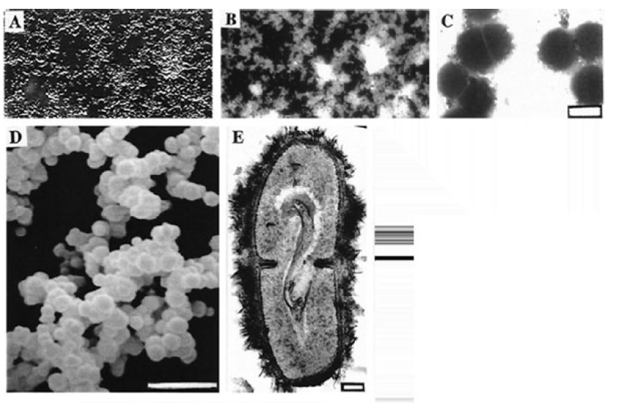

Light and electron microscopic images of nanobacteria.

(A) DIC image of bottom-attached nanobacteria after a 2-month culture period.
(B) DNA staining of the same area (X1600) with the modified Hoechst method.
(C) Negative staining of nanobacteria isolated directly from FBS. (Bar = 200 nm.)
(D) SEM micrograph showing their variable size. (Bar = 1 μm.)
(E) A dividing nanobacterium covered with a "hairy" apatite layer. (Bar = 100 nm.)

Source: Kajander and Ciftcioglu 1998 (PNAS 95: 8274-8279).
Copyright 1998 National Academy of Sciences, U.S.A. Used with permission.
Part III – More Evidence of Life

In their 1998 paper, Kajander and Ciftcioglu describe various experimental results to support their hypothesis that nanobacteria are living organisms. In addition to the evidence you have already considered, these authors describe three key experiments that they feel greatly strengthen their hypothesis.
Experiment 1—Transferability
When nanobacteria are cultured for a period of time (1 month), the process of biomineralization that they trigger results in the formation of a "biofilm" on the surface of the culture container - much like a hardwater deposit around a faucet. It is possible to scrape up this biofilm, dilute the components (1:10), and transfer the nanobacteria into a new culture container. After another month, the culture container is once again coated with a biofilm. They describe this property as "transferability."
Experiment 2—Gamma Radiation
Nanobacteria could be isolated from culture as described above. When these isolated cells were exposed to high energy, gamma radiation and then added to a culture container, it was observed that no growth of a biofilm was observed. Gamma radiation is fatal to cells.

Experiment 3—Kidney Stones
Kidney stones were examined from 30 different human patients. When these stones were treated to slightly dissolve them, it was possible to isolate nanobacteria-like particles. When placed in culture, these particles behaved exactly like nanobacteria isolated from serum. That is, they formed a biofilm on the surface of the culture container.
Consider the results from each of the three experiments described above. What does each experiment tell you?
How does the experiment support the hypothesis that nanobacteria are living? Use the table below to record your thoughts.

 | What can you conclude from this experiment? | Does the experiment support the hypothesis?
Experiment 1
Experiment 2
Experiment 3

Part IV—Corroborating Evidence

A key requirement in the process of scientific investigation is the repetition of experimental results by other scientists. If others can repeat your work, then it is likely (although not guaranteed) that your conclusions and hypotheses are correct. In October of 2000, Cisar et al. (et al. means "and others") published a paper that examined the original work of Kajander and Ciftciolglu.

Cisar's team repeated the experiments described by Kajander. They isolated and cultured the nanobacteria in the same way and observed many of the same behaviors. Despite this, Cisar et al. believe that their evidence does not support the hypothesis that nanobacteria are living and play a role in the development of kidney stones in humans.

One difference between the papers focuses on the evidence for DNA. DNA can be identified by its staining properties (Hoechst or ethidium bromide) or by its ability to absorb light at a wavelength of 260nm (ultraviolet). Another method is to use the technique of Polymerase Chain Reaction (PCR). This technique uses short sequences of DNA called primers to trigger a chemical reaction that increases the concentration of pieces of a specific region of DNA from a sample. ( The data from these and other experiments are presented on Data Sheet 1)

The critical analysis of data becomes even more important when different groups reach conflicting conclusions. Scientific results are meaningless if they cannot be repeated and validated. The inability to repeat results could arise from unknown variables (quality of water, etc.), from minor changes in technique or procedure, from differences in interpretation (researcher bias), or from serious flaws with the original research.

1. What is Cesar et al’s position on whether nanobacteria are alive or not? Find a sentence or phrase that identifies this position and highlight it.

2. Why might scientists NOT be able to repeat the results from a previous experiment?

3. Consider the evidence gathered by Kajander’s team. What evidence would it take for your group to decide that the nanobacteria are NOT alive and that Kajander is wrong?

DATA SHEET 1
Experiment | Result of Cesar et al’s research - repeating the work of Kajander | Supports hypothesis that nanobacteria are alive? (yes/no)
Culture of  Nanobacteria | Nanobacteria maintained in culture generate a biofilm on the surface of the culture container within 3 weeks.
Gamma  Radiation | Exposure to gamma radiation prevents the formation of a biofilm.
Transferability | When a biofilm (nanobacteria) isolated by scraping the surface of an established culture and transferred into a new culture container - generating a new biofilm. This could be repeated for several months.
Cell-like  appearance | The nanobacteria isolated from the biofilm has a coccoid (round) appearance.
DNA Isolation | There is no evidence of DNA based on absorption at a wavelength of 260nm.
PCR for DNA | The same PCR product was found in 2 samples that lacked the nanobacteria.  1) The sequence of the PCR product was 99% identical to that of Pseudomonas, a common bacterial contaminant.  2) The published sequences of rDNA from nanobacteria are 99% identical to rDNA from Phyllobacterium, another common contaminant.

1. Consider the data from the work by Cisar et al. Which terms or techniques might be difficult for novice biologists to understand? Clarify them with your group and with other resources. Describe at least 2 concepts that might need clarification below.

2. Based on Cesar’s data, do nanobacteria have DNA? Why would this be important for establishing that nanobacteria are living organisms?

Part V—Final Chapter (or is it?)

When Cisar et al. tried to repeat the experiments described by Kajander and Ciftciolglu, they did not feel that the results they obtained supported the hypothesis that nanobacteria were living. Cisar et al. claim to provide evidence that there is no DNA associated with the nanobacteria based on DNA staining and that evidence of nanobacterial rRNA is likely a result of contamination of the PCR results by other common bacteria.

While these results seemed to support the idea that nanobacteria are not biological organisms, there was a problem. Cisar et al. were able to repeat some of Kajander and Ciftciolglu's data. Specifically, Cisar et al. found that, nanobacteria could 1) generate a biofilm, 2)gamma radiation prevented the formation of the biofilm, and that 3)the biofilm could be transferred.
What could account for these results if nanobacteria were not alive? Cisar et al. needed to explain these results if they wanted their conclusion to be accepted by the scientific community. They attempted to do this by this by designing an additional set of experiments.
Assignment for Part V:

It is not enough to simply suggest that someone else's research is wrong. The finding of "negative evidence" (not finding something) is usually not sufficient. You must provide compelling, positive evidence that offers an alternative explanation of the published observations.

Look over the final set of experimental data provided by Cisar et al. and displayed on the chart. What conclusions can you make?

Experiment | Results of Cesar’s new experiments | Conclusions based on this data
Energy Use by Nanobacteria | Cultures of nanobacteria were exposed to 0.1% sodium azide - a powerful inhibitor of cellular respiration. The formation of a biofilm continued even in the presence of this poison.
“Growth of Dilute Cultures” | Cultures of nanobacteria were diluted to a higher degree than that used by Kajander. Dilutions of 1:100 or 1:1000 were cultured At these high dilutions there was no evidence of biofilm formation even after 8 weeks.
Biofilm formation in the absence of nanobacteria | Sterile culture media will not form a biofilm on its own. When purified phosphotidyl inositol (a phospholipid common to biological membranes) was added to the culture, biofilm formation occurred within two weeks. The appearance of the particles was very similar to those found in nanobacterial cultures.  This ability for a phospholipid to induce biofilm formation was prevented when the phospholipid was exposed to gamma radiation.
Conclusion – The Debate

Scientific theories are based on our best understanding of the evidence. These theories must either be modified or abandoned when new evidence is made available that challenges our understanding. In this case study you have been asked to consider experimental results from two competing labs.
The contradictory data reported by the two groups resulted in the publication of an independent news item entitled "Researchers fail to find signs of life in 'living' particles" by Allison Abbott (Nature Vol 408:394, 2000).
In this article Cisar is quoted as saying, "There is a need for hard molecular evidence" to support a claim of life, while Ciftcioglu is quoted as saying, "We have evidence that the particles are living. We are not fanatics, we are scientists.” Who is right?
Final Project - Each member of the group must submit their own essay.

Discuss which set of evidence (Kajander and Ciftcioglu or Cisar et al.) you find most convincing. Decide whether you believe nanobacteria are alive or not!

Write a 1 page essay that states your position and discusses why you feel that way. You must include details and evidence from this case study to support your position.

Originally published at http://www.sciencecases.org/nanobacteria/nanobacteria.asp
Adapted for AP Biology (High School)

