Organic Chemistry
Organic Compounds - have carbon bonded to other atoms and determine structure/function of living things
What are inorganic compounds?
Organic compounds features:
1.
2.
3.
4.
Examples of organic molecules:
Attached to the carbon skeleton is a FUNCTIONAL GROUP- which is the area that participates in chemical reactions
Functional Group |  | Name of compounds | Functions
Hydroxyl | -OH | Alcohols | hydrophilic, polar
Carbonyl | -CO | Aldehydes (when the =O occurs at the end of chain)  Ketones (when the =O occurs in the middle of chain) | hydrophilic, polar
Carboxyl | -COOH | Carboxylic Acids | act as acids, donate protons
Amino | -NH₂ | Amines | act as bases, accept protons
Types of alcohols:

What type of compounds are the following? How are they used?
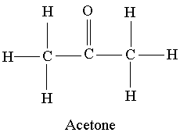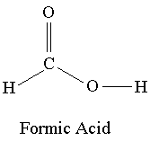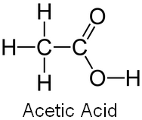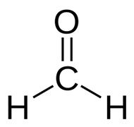

MACROMOLECULES fall into four major groups
1. Carbohydrates 2. Lipids 3. Proteins 4. Nucleic Acids

1. CARBOHYDRATES
monosaccharides - simple ring sugars, ex:
disaccharides - two monosaccharides combined, ex:
polysaccharides - polymers (long chains of repeating units) of monosaccharides,
starch (plant energy storage)
glycogen (animal energy storage)
cellulose - structural molecule, plant cell walls
chitin - structural molecule, exoskeletons
pentoses - five carbon sugars; deoxyribose & ribose (DNA)

2. Lipids
Hydrophobic (insoluble in water)
Used for -
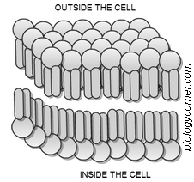
Fats & Oils are made of subunits - glycerol and fatty acids
Waxes – mainly used for covering and protection

Phospholipids - Important structural component of the cell membrane
Steroids - cholesterol & sex hormones
(estrogen & testosterone) – made of 4 fused rings

*Saturated fats contain no double bonds, unsaturated have double bonds that “kink” the molecule
*Saturated fats solidify at room temperature; unsaturated fats are liquid at room temperature
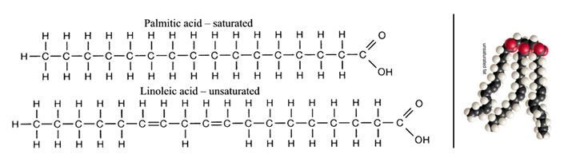
What is a trans fat?

3. Proteins
- Polymers made of amino acids, which are joined by peptide bonds - proteins are also called polypeptides
- Amino acids form a wide variety of structures, mainly building blocks for living tissue
Also used for:
- Proteins can be denatured:

Proteins have four shapes:

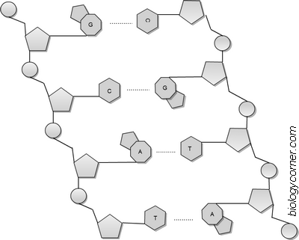
4. Nucleic Acids
- Informational polymers made of individual nucleotides
- DNA (deoxyribonucleic acid) & RNA (ribonucleic acid)

Each nucleotide consists of:

ATP (adenosine triphosphate) -

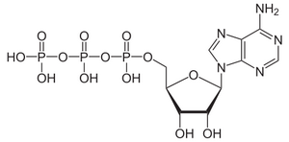 <<<<<<<<<<<<< Molecule of ATP stores energy
QUIZ YOURSELF!
a. carbohydrate b. lipids c. protein d. nucleic acids
1. contains adenine and thymine
2. lactose
3. chains of amino acids
4. long term energy storage
5. cholesterol
6. chains of fatty acids and glycerol
7. plant cell walls

Publisher: Biologycorner.com;
This work is licensed under a Creative Commons Attribution-NonCommercial 3.0 Unported License.

