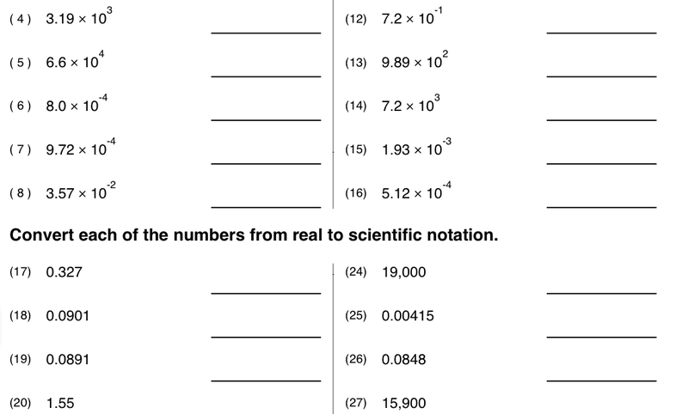

Name_____________________________ Date___________________________

Period__________________________

Convert the scientific Notations to the actual number it represents