Unit 8: DNA (notes packet, ALL notes at biologycorner.com)

13-1: The Genetic Material
How was DNA discovered to be the chemical unit of heredity?
Scientists already knew that chromosomes played a role in heredity, but the chemical composition of the chromosome included DNA and proteins. At the time, they did not know which molecule actually contained the hereditary information.

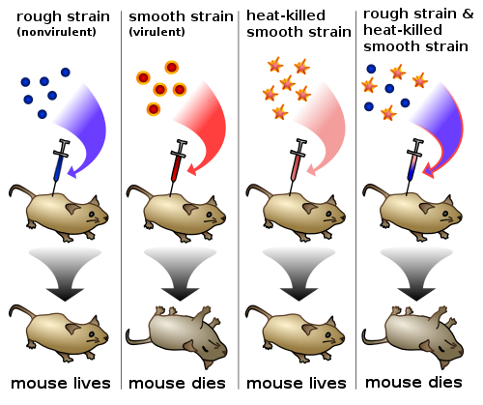
Frederick Griffith's Experiment - Transformation
Using two varieties of streptococcus, he originally searched for a vaccine. One variety of bacteria had a capsule (like a cell wall) the other did not have a capsule.
1. Injection with live encapsulated bacteria -- mice contracted pneumonia and died
2. Injection with live naked bacteria -- mice lived, immune system destroyed the bacteria
3. Injection with heat killed encapsulated bacteria -- mice remained healthy
4. Injection with dead encapsulated bacteria and live naked bacteria -- mice contracted pneumonia and died
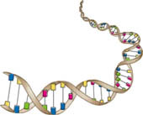
*note that neither of this forms caused disease before, but when placed together something occurred to make the living naked bacteria virulent.

What conclusions can be drawn from the experiment?
Living bacteria acquired genetic information from dead bacteria - particularly the instructions for making capsules, thus transforming the naked bacteria into encapsulated bacteria. The Transforming agent was discovered to be DNA. DNA was isolated and added to live naked bacteria, and they were transformed into the encapsulated kind.

The Hershey-Chase Experiment - Bacteriophage
1. Hershey and Chase forced one population of phages to synthesize DNA using radioactive phosphorous.
2. The radioactive phosphorous "labeled" the DNA.
3. They forced another group of phages to synthesize protein using radioactive sulfur.
4. The radioactive sulfur "labeled" the protein. **DNA contains phosphorous but not sulfur. **Proteins contain sulfur,not phosphorous
5. Bacteria infected by phages containing radioactive protein did not show any radioactivity.
6. Bacteria infected by phages containing radioactive DNA became radioactive.
7. This showed that it was the DNA, not the protein that was the molecule of heredity.
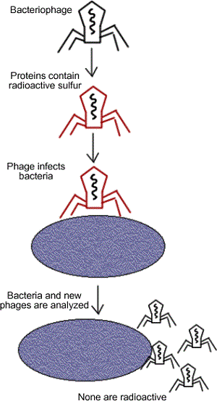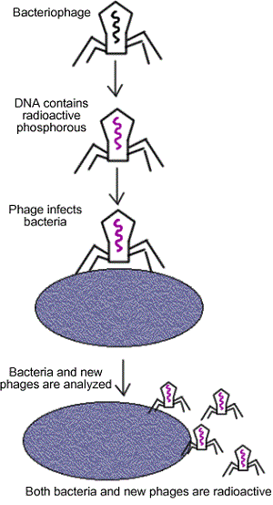

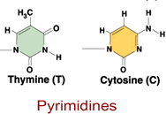
13-2 The Structure of DNA
Chargaff analyzed the amounts of the four nucleotides found in DNA
1. The amount of A, T, G, C varies from species to species
2. In each species, the amount of Adenine equals Thymine,
3. The amount of Guanine equals Cytosine - This is the Base Pair Rule
Rosalind Franklin and Wilkins spent time taking X-ray diffraction
Watson and Crick established the structure as a double helix -
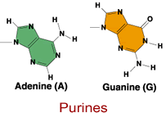
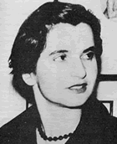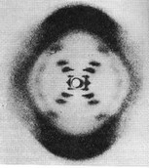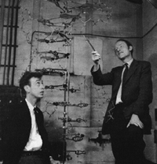

The sugar (deoxyribose) and phosphates make up the "backbone" of the DNA molecule.
The phosphate is attached to the 5' carbon (the 5 is a number given to sugar molecules). The DNA strand has a free phosphate on the 5' end, and a free sugar on the 3' end - these numbers will become important later.

Adenine always pairs with Thymine | Guanine always pairs with Cytosine

Side1:: A A T T G G C C A G A T A C
Side2:: T T A A C C G G T C T A T G

DNA is composed of subunits called nucleotides, strung together in a long chain --
Each nucleotide consists of: a phosphate, a sugar (deoxyribose), and a base, arranged ANTIPARALLEL
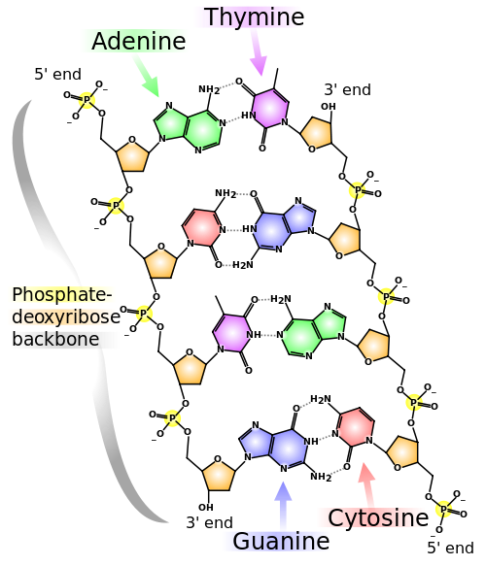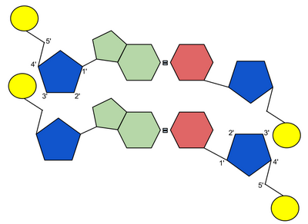

13-3: DNA Replication
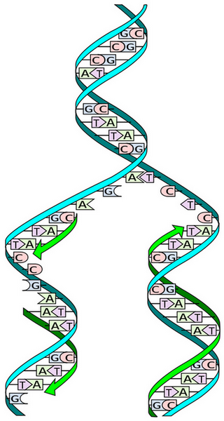
-the process by which DNA makes a copy of itself
-occurs during interphase, prior to cell division

1. DNA helicase (enzyme) unwinds the DNA. The junction is called a replication fork.
2. DNA polymerase adds the complementary nucleotides and binds the sugars and phosphates. DNA polymerase travels from the 3' to the 5' end. The DNA is called the template strand.
3. DNA polymerase adds complementary nucleotides on the other side of the ladder. Traveling in the opposite direction.
4. One side is the leading strand - it follows the helicase as it unwinds.
5. The other side is the lagging strand - its moving away from the helicase (in the 5' to 3' direction).
Replication is called semi-conservative, because one half of the original strand is always saved, or "conserved"
Problem: it reaches the replication fork, but the helicase is moving in the opposite direction. It stops, and another polymerase binds farther down the chain.
This process creates several fragments, called Okazaki Fragments, that are bound together by DNA ligase.
6. During replication, there are many points along the DNA that are synthesized at the same time (multiple replication forks). It would take forever to go from one end to the other, it is more efficient to open up several points at one time.
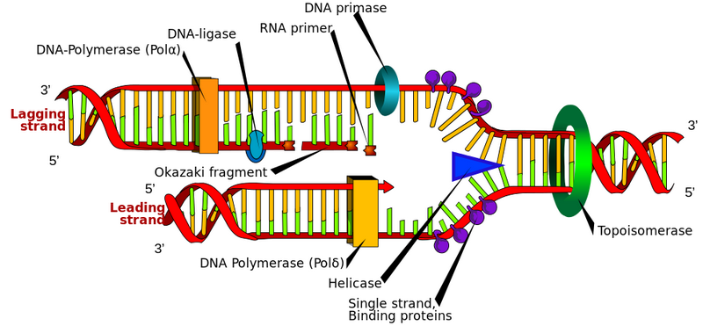

Replication Errors – can cause a genetic MUTATION
-- PROOFREADING by the polymerase prevents mismatches
-- DNA REPAIR ENZYMES can repair damaged DNA also

*DNA replication is best understood by viewing the animations*

14-1 The Function of Genes ****Genes specify a proteins****
George Beadle’s Experiment showed that mutated bread mold will fail to make a particular enzyme and will not grow on minimal medium (“One Gene, One Enzyme Hypothesis”)

Conclusions: A gene is a segment of DNA that specifies the sequence of amino acids in a polypeptide of a protein. (this is the definition of a gene)
Gene Expression
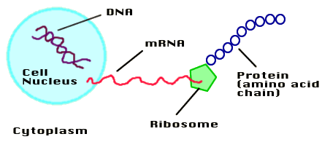
Three Important Points to Remember 1) Chromosomes are made of DNA 2) Segments of DNA code for a protein 3) Protein in turn, relates to a trait (eye color, enzymes, hormones..)

How Proteins are Synthesized from DNA

1. DNA is transcribed into mRNA (messenger RNA)
2. mRNA leaves the nucleus and travels to the cytoplasm
3. Ribosomes in the cytoplasm use the code on mRNA to translate it into amino acids
4. Amino acids form a chain - a protein

This is also sometimes referred to as “The Central Dogma”

Transcription
RNA is very similar to DNA with the following exceptions:
it is single stranded | it has uracil instead of thymine | it has the sugar ribose, instead of deoxyribose
The base-pair rule is followed during transcription, except, instead of pairing thymine with adenine, when creating an RNA strand, uracil is used
DNA Strand: T G C A T C A G A
RNA Strand: A C G U A G U C U

Transcription begins on the area of DNA that contains the gene. Each gene has three regions:

1. Promoter - turns the gene on or off, defines the start of a gene
2. Coding region - has the information on how to construct the protein
3. Termination sequence - signals the end of the gene
4. Some have regulatory switches (Pitx1 gene in sticklebacks, from case study)

RNA Polymerase is responsible for reading the gene, and building the mRNA strand. It reads only the 3' to 5' strand.
Introns – areas of the RNA that will not be expressed and are spliced out Exons – areas of RNA that will be expressed
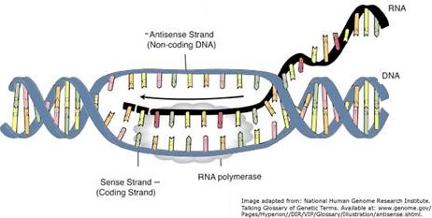

**Animations of this process will be very helpful**

Translation

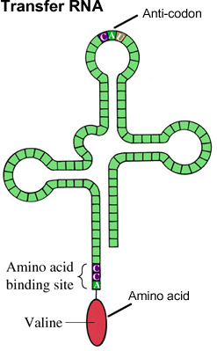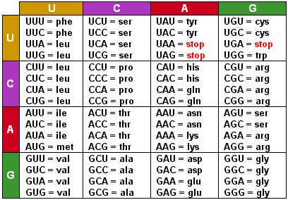
1. The mRNA travels to the cytoplasm
2. Amino acids exist freely in the cytoplasm, many of them you acquire from your diet
3. Each 3 bases (codon) translates to a single amino acid. (See codon chart)
4. The ribosome looks for the "start" codon - AUG, this is where the chain begins
5. Transfer (tRNA), has an anticodon at one end and an amino acid at the other, it binds to a complementary codon.
6. Another tRNA reads the next codon, the amino acid attached to it binds with the amino acid on the previous tRNA using a peptide bond. The first tRNA falls off.
7. This process continues until the "stop" codon is reached.
8. The amino acid chain folds into a 3 dimensional structure, now a protein.
9. That protein can be an enzyme, a hormone, or any other structure in the body that gives it traits and functionality.

Test for Understanding

1. A DNA sequence has the following bases: What amino acids does it code for? (You'll need to use the codon chart)

T A C - A G A - T T A - G G G - A T T

2. Label the diagram:
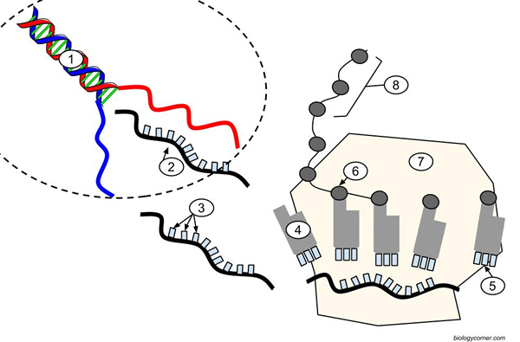
Chapter 15: Regulation of Gene Activity
Experiments with E. Coli showed that it is capable of regulating the expression of its genes
An operon consists of the following elements

1. Promoter - where RNA polymerase attaches, signalling the start of the gene
2. Operator - where repressor binds, stopping the transcription of that gene
3. Structural Genes - code for an enzyme, transcribed as a unit
Example: the trp Operon controls the production of tryptophan
Tying it all together - the Lac Operon Gene

E. Coli bacteria can synthesize lactase, which is an enzyme that breaks down lactose. Lactase is only synthesized in the presence of lactose. If there is no lactose in the environment, the gene is repressed. Since they live in the intestinal tract of humans, they must live on whatever the host eats. When you drink milk, you are provided your E. Coli bacteria with lactose.
- E. Coli has three genes (6, 7, 8) that code for lactase.
- It also has a promoter (1) and an operator (2)
- Without lactose, the lac repressor binds to the operator site.
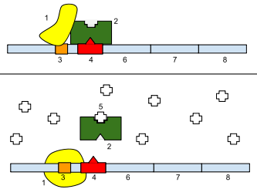
- With lactose (5), the repressor is removed
- Once repressor is removed, RNA polymerase binds to the promoter
- RNA is transcribed, the genes (6,7,8) code for lactase

Repressors turn transcription OFF(tryp operon)
Inducers turn transcription ON (lac operon)
15.3 Gene Mutations
Point Mutation - substitute one base for another
Original: A T A C A C
Mutant : T T A C A C

Frameshift Mutation - a base is either added or removed which causes a shift in the reading frame. Many genes affects
Original: A T A C A C A A G C C A
Mutant: A T T A C A C A A G C C A

Silent Mutation - a base is changed but the resulting amino acid is the same as in the non mutant DNA. No outward changes.
Original: A A A C A G
Mutant: A A G C A G

Nonsense Mutation - a codon is changed to a STOP codon
Original: A T A C C C A A A
Mutant: A T T C C C A A A

Modern Genetics Concepts

Oncogenes
Transposons
Regulatory Switches (enhancers)
SNPS
Epigenetics
Homeobox (HOX genes)

